**Message Validator**

1. Specify the Data Encoding of the message being validated.
2. Select the Message Type of the message being validated. Auto-detect will do its best to determine what type of message the data is, but will not work for all messages. If a message is a sub-type of another message type, then the highest level will be identified. For example, a Frame+TIM message is of message type MessageFrame, but MessageFrame is a sub-type of ServiceRequest.

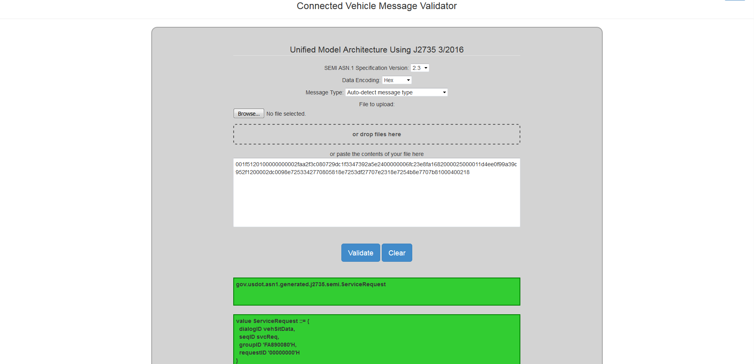

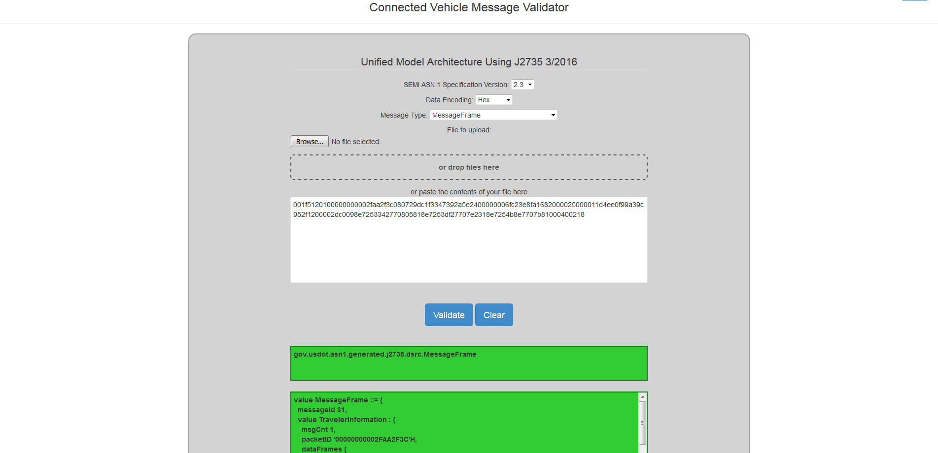

If a message is failing to validate, switching the Message Type from Auto-detect to the specific message type could allow the validator to properly decode the message or provide a more specific error message to the issues with the message.

1. To specify the message, you can browse the file system for the message file, drag and drop the message file unto the box with the dotted line border, or enter the contents of the file in the provided text area.

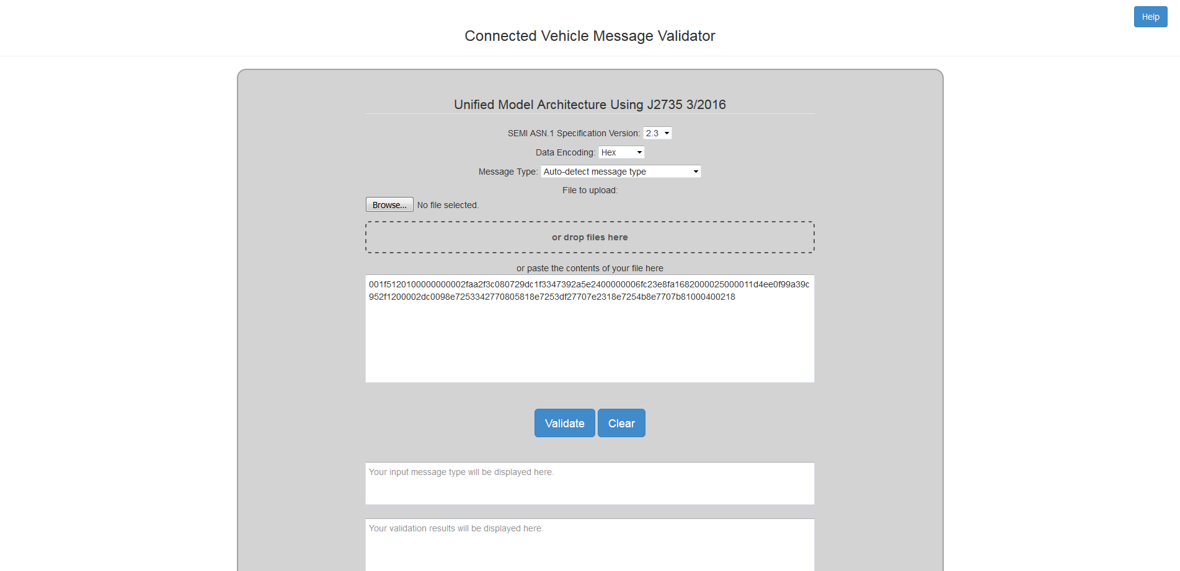

1. Hit the **Validate** button to validate the message.
   * If the message is valid, the text areas at the bottom will change to green. The fully qualified message type and decoded value will be displayed within the text areas.

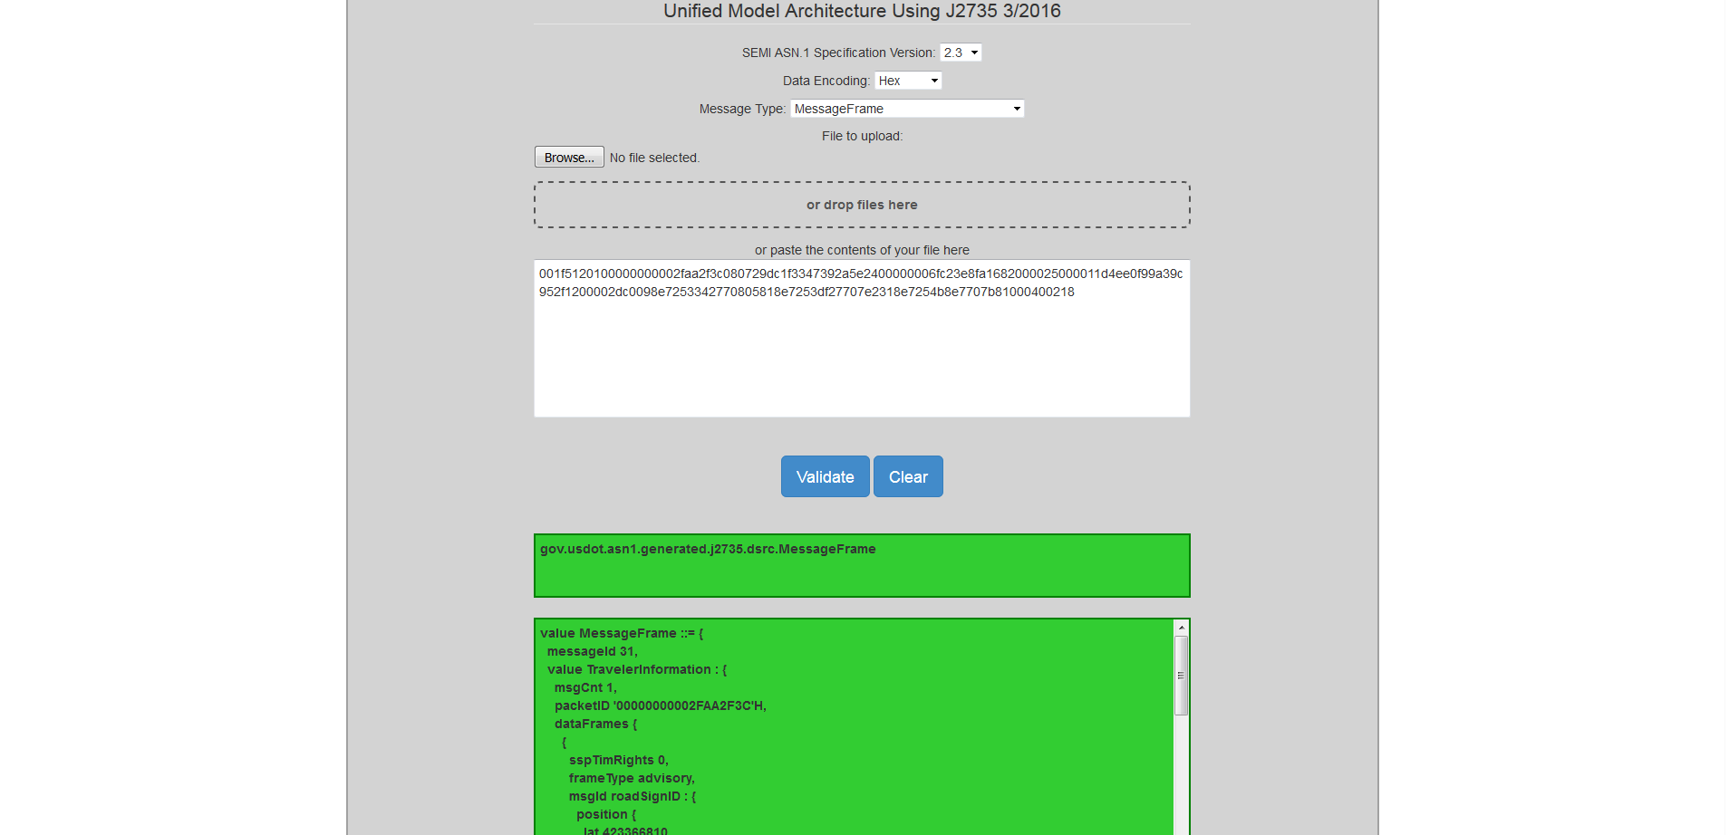

* + If the message is not valid, the text areas at the bottom will change to red. A brief error message as well as a more detailed error message will be displayed within the text areas.

